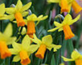

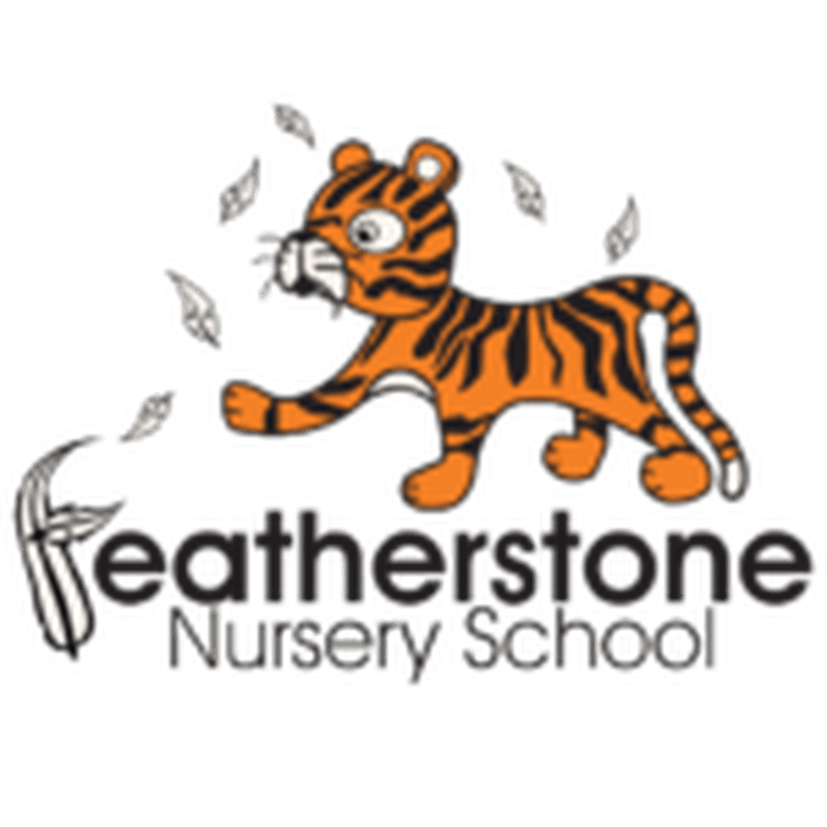
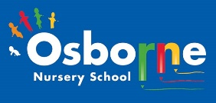
Spring 2 - Spring into Action and Keeping Healthy!
Federation of Osborne and Featherstone Nursery Schools Curriculum Guide for Parents and Carers
2 Year Olds | 3 Year Olds | 4 Year Olds
Key Activities:  Children will explore tasting different fruit and vegetables and learn names. They will experience digging in the allotment and learn that plants need water. Children will be encouraged to join in with Wake up Shake up, Dough Disco and follow simple actions. They will be encouraged to be physically active and explore their bodies and link their actions to Startwell characters. | Key Activities:  Children will plant different seeds, plants and bulbs in the allotments and care for them. They will observe growth and change and be able to explain the basic needs of plants. They will learn about signs of spring.  The children will experiment with different ways to move and develop their confidence to try new things. They will use numbers in play. | Key Activities:  The children will learn about 5 a day and learn about which foods help us to grow and which foods we should limit. They will explain they can look after themselves (sleep, food, exercise, limiting screen time)  The children will be able to talk about harvest and the food they have grown. They will experience cooking different foods
Core books to read:  Looking at lots of non-fiction picture books about food and gardening.  Orange, Pear, Apple, Bear by Emily Gavett, Banana by Ed Vere, Each, Peach, Pear, Plum by Janet Alberg. | Core books to read:  The very Hungry Caterpillar and One Tiny Seed—Eric Carle, 10 Little Seeds by Ruth Brown,  One Mole Digging a Hole by Julia Donaldson, Titch stories by Pat Hutchins | Core books to read:  Oliver’s Vegetables by Vivian French, Handa’s Surprise by Eileen Browne, Daisy Eat Your Peas by Nick Sharratt,  Octopants by Suzy Senior
Important words to learn:  Naming lots of fruits and vegetables  Learning words linked to gardening— tools, fork, spade, trowel, rake  Movement words—fast, sow, up, down, run, hop, climb, skip | Important words to learn:  Children will use correct language to ask for tools in the allotment.  Counting—one to ten, measuring language—long, tall, short, small, wide. Describe where something is—on, behind, in, out | Important words to learn:  Language of growth—big, bigger, huge, enormous, little, tiny, small, growing, change  Cooking—fry, boil, bake, mix, kneed, oven, cooker  Words related to healthy lifestyles—exercise, beat, heart, faster, blood, clean, brush, sleep, decay, energy, sugar, salt
How can you help at home? Continue to sing! Tap out rhythms and listen to sounds. Look at food at home—name foods, talk about tastes, cook together! Get out and about - running, hopping, climbing, skipping. | How can you help at home? What is growing in the gardens nearby? Look at the similarities and differences between plants, maybe you could plant some seeds at home? Read together and talk about stories | How can you help at home? Enjoy physical exercise together, talk about ways to stay healthy—teeth, foods, sleeping, exercising! Share cooking together—look at recipes and prepare foods to cook. Read together and look for letter sounds.

